THE NEWS APP

# Introduction

This project, titled "News App Frontend", is designed to create a user-friendly interface for a news application using only HTML and CSS. The primary objective of this project is to design and develop a visually appealing and responsive layout that displays news articles in an organized and structured format.

The News App offers sections for different categories such as politics, sports, entertainment, technology, and more. It focuses entirely on the frontend design, showcasing how modern web technologies like HTML for structure and CSS for styling can be used to build an intuitive and clean user interface.

This project highlights responsive design techniques, ensuring the app works well on different devices like desktops, tablets, and mobiles. Though this project does not include backend or live news fetching functionality, it serves as a strong foundation for future integration with APIs or databases.

Overall, the News App Frontend Project demonstrates the effective use of HTML and CSS in developing professional and user-friendly web interfaces.

# 2. Languages Used

1. **HTML(Hyper Text Markup Language)**

HTML is used to create the structure of the web pages. It defines elements such as headings, paragraphs, images ,lists, link ,and buttons. In this project, multiple HTML files are used to organize different recipe categories and pages.

# CSS(Cascading Style Sheets)

CSS is used to style the website and enhance the user experience. It controls the layout, colors, fonts, and responsive behavior of the pages. This project uses external CSS (style.css) to maintain consistency across different pages.

# 3. Coding

**Welcome.html**

<!DOCTYPE html>

<html lang="en">

<head>

<meta charset="UTF-8">

<meta name="viewport" content="width=device-width, initial-scale=1.0">

<title>News letter Subscription</title>

<style>

/* Body Styling */

body {

font-family: Arial, sans-serif;

display: flex;

justify-content: center;

align-items: center;

min-height: 100vh;

margin: 0;

background-color: #f4f4f4;

flex-direction: column;

overflow: hidden;

animation: backgroundColorChange 10s infinite; /* Animation for background color change */

}

/* Top image styling */

.top-image {

position: absolute;

top: 0;

left: 50%;

transform: translateX(-50%);

width: 100%;

max-width: 600px;

height: auto;

z-index: 1000;

}

/* Welcome Text Styling */

.welcome-text {

position: absolute;

top: 10%;

left: 50%;

transform: translateX(-50%);

font-size: 28px;

font-weight: bold;

color: #333;

text-align: center;

z-index: 1000;

}

/* Newsletter box styling */

.newsletter-container {

text-align: center;

padding: 20px;

background-color: #fff;

border-radius: 8px;

box-shadow: 0 0 10px rgba(0, 0, 0, 0.1);

width: 400px;

position: absolute;

top: 30%;

left: 50%;

transform: translate(-50%, -50%);

}

.newsletter-container h2 {

font-size: 24px;

margin-bottom: 10px;

color: #333;

}

.newsletter-container p {

font-size: 16px;

color: #666;

margin-bottom: 20px;

}

.input-container {

display: flex;

gap: 10px;

justify-content: center;

}

.input-container input[type="email"] {

padding: 10px;

border: 1px solid #ccc;

border-radius: 4px;

width: 300px;

}

.input-container button {

padding: 10px 20px;

background-color: #00ff62;

color: #fff;

border: none;

border-radius: 4px;

cursor: pointer;

}

.disclaimer {

font-size: 12px;

color: #999;

margin-top: 10px;

}

/* Animation for background color change */

@keyframes backgroundColorChange {

0% {

background-color: red;

}

25% {

background-color: #FF7A00;

}

50% {

background-color: green;

}

75% {

background-color: goldenrod;

}

100% {

background-color: violet;

}

}

</style>

</head>

<body>

<!-- Image at the top of the screen -->

<img src="front-image.jpg" alt="" class="front-image">

<!-- Welcome Text -->

<div class="welcome-text">

<p><h1>Welcome to Our News App!</h1></p>

</div>

<p>Stay updated with the latest news and trends.</p>

<div class="newsletter-container" id="newsletter-box">

<h2>Subscribe to the NewsLetter</h2>

<p>Stay updated with the latest news and trends.</p>

<div class="input-container">

<input type="email" placeholder="Enter Your Email" id="email-input">

<a href="Technology.html"><button id="Subscribe">Subscribe</button>

</div>

</div>

<script>

document.addEventListener("DOMContentLoaded", function () {

let newsletterBox = document.getElementById("newsletter-box");

function adjustAlignment() {

let windowHeight = window.innerHeight;

let windowWidth = window.innerWidth;

newsletterBox.style.top = windowHeight / 2 + "px";

newsletterBox.style.left = windowWidth / 2 + "px";

newsletterBox.style.transform = "translate(-50%, -50%)";

}

// Adjust alignment on window resize

window.addEventListener("resize", adjustAlignment);

adjustAlignment();

});

</script>

</body>

</html>

**Technology.html :**

<!DOCTYPE html>

<html lang="en">

<head>

<meta charset="UTF-8">

<meta name="viewport" content="width=device-width, initial-scale=1.0">

<title>Technology</title>

<link rel="stylesheet" href="Technology_styles.css">

</head>

<body>

<header>

<h1>Technology</h1>

<nav>

<ul>

<li><a href="#ai">Artificial Intelligence</a></li>

<li><a href="#blockchain">Blockchain</a></li>

<li><a href="#iot">Internet of Things</a></li>

<li><a href="#5g">5G Technology</a></li>

</ul>

</nav>

</header>

<main>

<section id="ai" class="tech-section">

<h2>Artificial Intelligence (AI)</h2>

<img src="ai-image.jpg" alt="AI image" class="tech-image">

<p>

Artificial Intelligence (AI) is revolutionizing the tech industry. AI systems are capable of performing tasks that typically require human intelligence,

such as image recognition, decision-making, language translation, and more. Machine learning, a subset of AI, allows systems to learn from data and improve

over time.

</section>

<section id="blockchain" class="tech-section">

<h2>Blockchain</h2>

<img src="blockchain-image.jpg" alt="" class="blockchain-image">

<p>

Blockchain is a decentralized and distributed ledger technology that ensures secure and transparent transactions. It's most commonly known for its

use in cryptocurrencies like Bitcoin, but it is also being used in supply chain management, healthcare, and various other sectors.

</p>

</section>

<section id="iot" class="tech-section">

<h2>Internet of Things (IoT)</h2>

<img src="Internet of Things.jpg" alt="" class="IoT-image">

<p>

The Internet of Things (IoT) refers to the network of physical objects that are connected to the internet, allowing them to send and receive data.

Smart homes, wearable technology, and autonomous vehicles are all examples of IoT applications.

</p>

</section>

<section id="5g" class="tech-section">

<h2>5G Technology</h2>

<img src="5g-image.jpg" alt="5G image" class="5g-image">

<p>

5G is the fifth generation of mobile network technology, offering faster speeds, lower latency, and greater connectivity. It is set to enhance

the performance of devices that rely on the internet, from smartphones to smart cities.

</p>

<a href="index.html"><button id="next">Next</button>

</section>

</main>

<footer>

<p>&copy; 2025 Technology Trends. All Rights Reserved.</p>

</footer>

</body>

</html>

**Technology.css:**

/* General reset and base styles */

* {

margin: 0;

padding: 0;

box-sizing: border-box;

}

body {

font-family: Arial, sans-serif;

background-color: #f4f4f4;

color: #333;

}

header {

background-color: #2c3e50;

color: white;

padding: 20px;

text-align: center;

}

header h1 {

font-size: 2.5em;

margin-bottom: 10px;

}

nav ul {

list-style-type: none;

padding: 0;

}

nav ul li {

display: inline;

margin: 0 20px;

}

nav ul li a {

color: white;

text-decoration: none;

font-size: 1.2em;

transition: color 0.3s ease;

}

nav ul li a:hover {

color: #3498db;

}

/* Main content area styling */

main {

padding: 20px;

}

.tech-section {

background-color: white;

margin-bottom: 30px;

padding: 20px;

border-radius: 8px;

box-shadow: 0 2px 4px rgba(0, 0, 0, 0.1);

}

.tech-section h2 {

font-size: 2em;

margin-bottom: 15px;

}

.tech-section img {

width: 100%;

max-width: 600px;

height: auto;

border-radius: 8px;

margin-top: 10px;

}

.tech-section p {

font-size: 1.1em;

line-height: 1.6;

margin-top: 10px;

}

/* Footer styling */

footer {

text-align: center;

background-color: #2c3e50;

color: white;

padding: 15px;

position: fixed;

bottom: 0;

width: 100%;

}

/* Media Queries for responsiveness */

@media (max-width: 768px) {

nav ul li {

display: block;

text-align: center;

margin: 10px 0;

}

.tech-section {

padding: 15px;

}

.tech-section h2 {

font-size: 1.5em;

}

.tech-section p {

font-size: 1em;

}

}

1. **Output:**

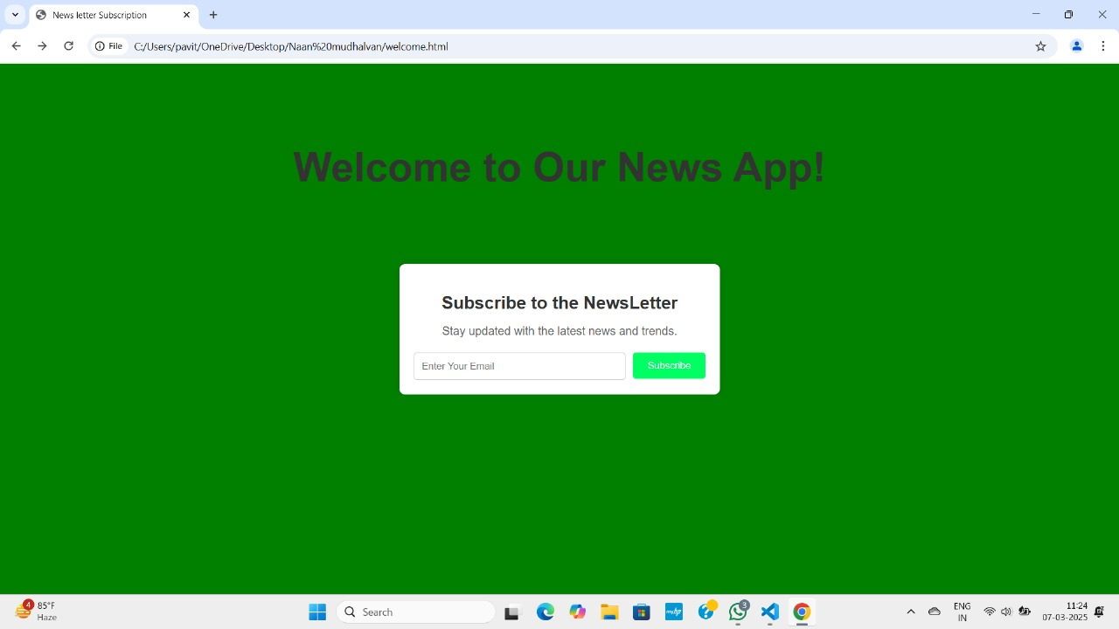

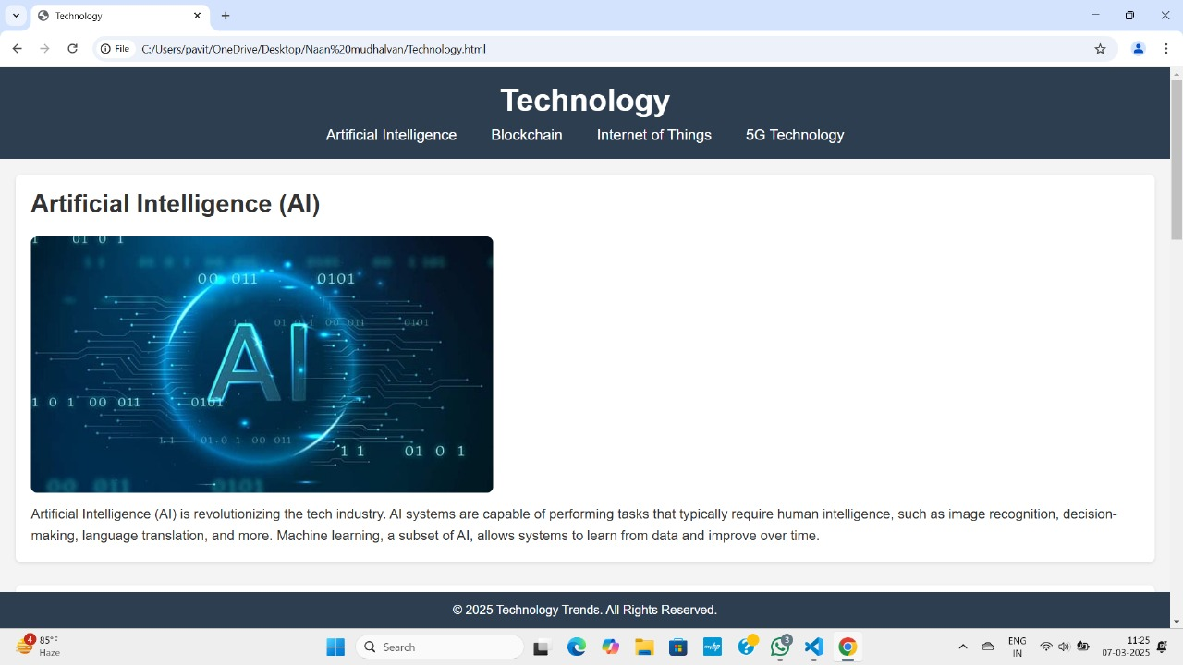

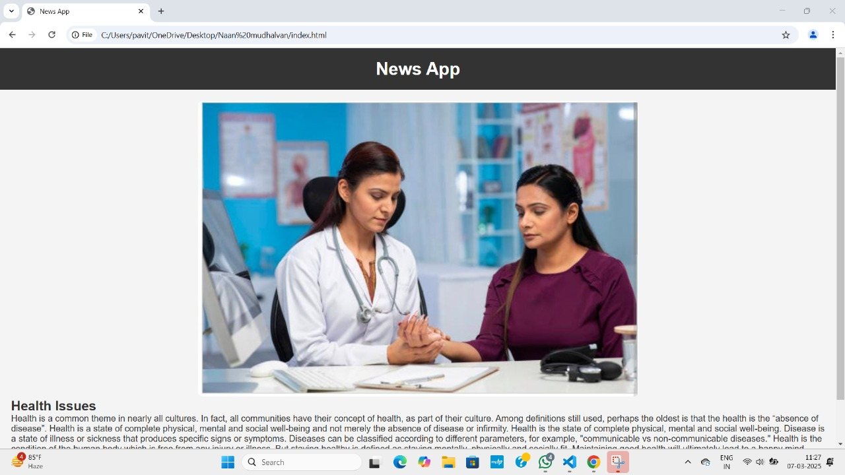

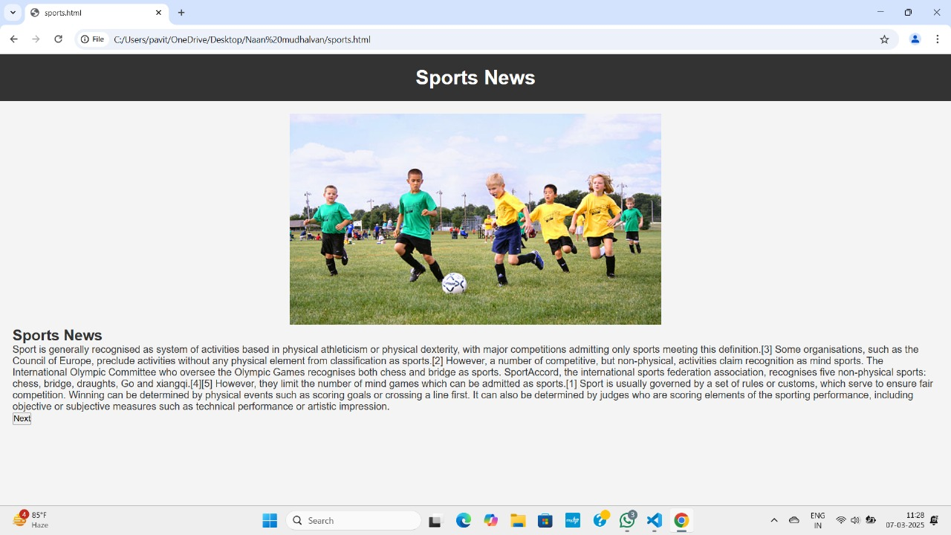

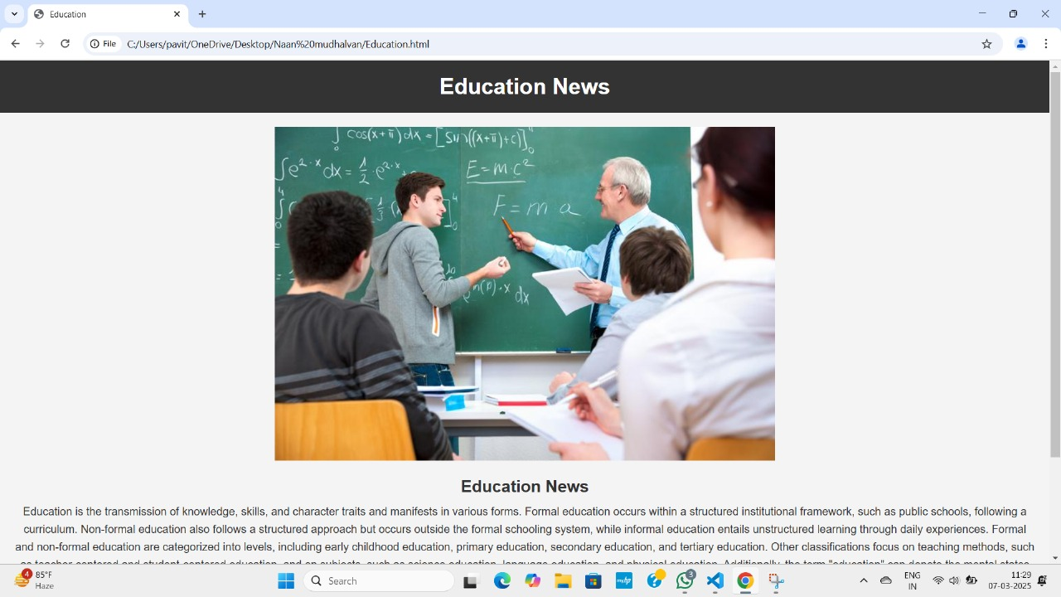

# 5. Conclusion

The News App Frontend Project successfully demonstrates the creation of a modern and responsive web interface using HTML and CSS. This project highlights the importance of visual design and user experience in web development. By organizing content into clear sections and ensuring proper responsiveness across devices, the project offers a solid foundation for any future enhancements, such as adding dynamic content using JavaScript or integrating live news data through APIs.

Overall, this project serves as a valuable learning experience in frontend development, showcasing the ability to design user-friendly layouts that are both aesthetically pleasing and functional.

.

# Future Improvements:

# In the future, the News App can be significantly enhanced by integrating live news APIs to fetch real-time news articles from various sources, ensuring users always have access to the latest updates. Adding user authentication would allow users to personalize their news feed by selecting preferred categories, such as sports, politics, technology, or entertainment. This personalized experience would make the app more engaging and relevant to each user’s interests.

# Additionally, the app can be improved by incorporating advanced search functionality, enabling users to find news articles based on keywords, dates, or topics. Features like dark mode, multi-language support, and offline reading capability would further enhance user convenience. The app can also support news bookmarking, allowing users to save articles for future reference. These enhancements would transform the News App into a fully-featured, user-centric platform for staying informed in a fast-paced digital world.

**THANK YOU**